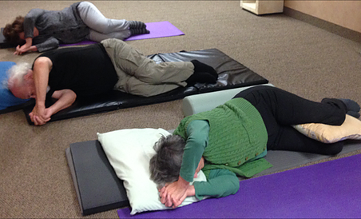  Ongoing Mondays @ 6pm & WEDNESDAY @ 11Am. please check website for any schedule modifications  For the JOY of What You LOVE!  Awareness through movement classes  Based on the Feldenkrais Method. Be able to do what you want better and easier, with less strain…more gain! Get back on top of your game!  Join us for gentle, yet challenging movement explorations designed to help you move, feel, and perform optimally in whatever activities you do. Bring a mat to lie on, and 1-2 towels for propping.  $15 for drop in class or 6 class package for $60 | Increase flexibility and strength, with ease and without increased pain!  ────  Improve balance and posture effectively!  ────  Feel more confident and fluid in your sport, hobby, or craft!  Awakening Movements Feldenkrais and Physical therapy  3121 Rochester Rd  Royal Oak, MI 48073  Inside of the Life Learining Center.  Parking and enterance are in back…watch step down when entering!  248-321-0358  AwakeningMovements.com

